* **Submit the following:**
  + Screenshot of the browser with your application running at:
    - [*http://your_ec2_ip:8080/api/user*](http://your_ec2_ip:8080/api/user)

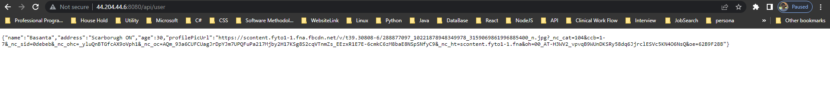

* + Also paste your api endpoint link, so that I can verify.

[**http://44.204.44.6:8080/api/user**](http://44.204.44.6:8080/api/user)

**GIT HTTPS link**

[**https://github.com/BasantaGhimire/getMeSocial_Service.git**](https://github.com/BasantaGhimire/getMeSocial_Service.git)

**Postman**

